MyGuitarFamily - Overview
A serverless, low-cost e-commerce architecture leveraging Netlify, Stripe, and Resend to deliver a fully functional custom-product ordering system with minimal infrastructure overhead.

📄 MyGuitarFamily – System Architecture Overview
🧭 High-Level Flow
Customer → Website (Netlify) → Stripe Checkout → Webhook (Netlify)
→ Email (Resend) → You (Fulfillment)

🧱 Core Providers & Responsibilities
🌐 1. Domain & DNS
Provider: GoDaddy (with Netlify DNS in use)
What it does:
- Owns myguitarfamily.com
- Controls DNS (domain routing)
- Delegates traffic to Netlify
Important details:
- You started with GoDaddy
- You moved DNS control to Netlify (NS1)
- GoDaddy is now mainly:
  - registrar (ownership)
  - not active DNS controller
Why it matters:
If DNS breaks → entire site/email stops working

⚡ 2. Hosting & Frontend
Provider: Netlify
What it does:
- Hosts your website (HTML, JS, CSS)
- Serves:
myguitarfamily.com
- Runs serverless backend functions:
  - create-checkout-session
  - stripe-webhook
Why it matters:
This is your application runtime (frontend + backend)

🧠 3. Code Repository
Provider: GitHub
What it does:
- Stores your source code
- Tracks versions (history)
- Triggers deployments to Netlify
Flow:
You edit → Commit → Push → Netlify auto deploys
Why it matters:
Single source of truth for your system

💳 4. Payments
Provider: Stripe
What it does:
- Handles checkout UI
- Processes payments (cards, etc.)
- Creates checkout sessions
- Sends webhook events after payment
Key concept:
Stripe = system of record for payments
Important pieces:
- Checkout Session
- Webhook (checkout.session.completed)

🔁 5. Backend Logic (Serverless)
Provider: Netlify Functions
What it does:
create-checkout-session.js
- Receives order from frontend
- Creates Stripe checkout session
- Attaches metadata (guitars, caption, etc.)
stripe-webhook.js
- Receives Stripe event
- Extracts order + metadata
- Sends email via Resend
Why it matters:
This is your business logic layer

📧 6. Email Delivery
Provider: Resend
What it does:
- Sends transactional emails
- Uses your domain:
orders@myguitarfamily.com
DNS setup includes:
- DKIM
- SPF
- MX
- DMARC
Why it matters:
Your order notification system

🎨 7. Product Builder (Frontend Logic)
Provider: Your custom JavaScript
What it does:
- Lets users build their guitar family
- Renders preview on:
<canvas id="lbCanvas">
- Generates:
  - structured order data
  - sticker image (PNG export)
Why it matters:
This is your actual product engine

🖼️ 8. Image Generation (NEW)
Provider: Browser (Canvas API)
What it does:
- Converts sticker preview → PNG:
canvas.toDataURL('image/png')
Current state:
- Export works ✅
- Not yet stored or sent to printer ❌
Why it matters:
This becomes your manufacturable asset

🔄 End-to-End Flow (Detailed)
Step 1 – Customer builds product
Frontend (Netlify)
→ Guitar selections
→ Canvas preview

Step 2 – Checkout initiated
Frontend → Netlify Function
→ create-checkout-session
→ Stripe Checkout URL returned

Step 3 – Payment
Customer → Stripe Checkout
→ Payment processed

Step 4 – Webhook triggered
Stripe → Netlify webhook
→ stripe-webhook.js

Step 5 – Order processed
Webhook extracts:
- Customer info
- Guitar metadata
- Options
→ Sends email via Resend

Step 6 – Fulfillment (Current)
YOU manually:
→ Read email
→ Build design
→ Send to printer

⚠️ What You HAVEN’T added yet (important)
🟡 Missing Components
1. Image storage (next step)
- Cloudinary / S3 / Supabase
- Needed for:
printer-ready file handling

2. Customer email confirmation
- Currently only YOU get email
- Customer gets nothing

3. Order persistence (database)
- No database yet
- Orders live only in:
  - Stripe
  - Email

4. Fulfillment automation
- No printer integration yet
- Fully manual

🧠 Architecture Summary
GoDaddy → owns domain
Netlify → hosts app + backend
GitHub → stores code
Stripe → handles payments
Resend → sends emails
Canvas → generates product image

🎯 Clean One-Line Summary
Netlify runs your app, Stripe takes money, Resend notifies you, GitHub manages code, and GoDaddy owns the domain.

🚀 Where you go next
You now have a complete commerce loop.
Next phases:
Phase 2
- Customer email
- Image storage
Phase 3
- Printer workflow
Phase 4
- Scaling / automation

If you want, next I can turn this into:
👉 a visual diagram (architecture map)
👉 or a one-page executive version
Both are useful depending on how you think about systems.

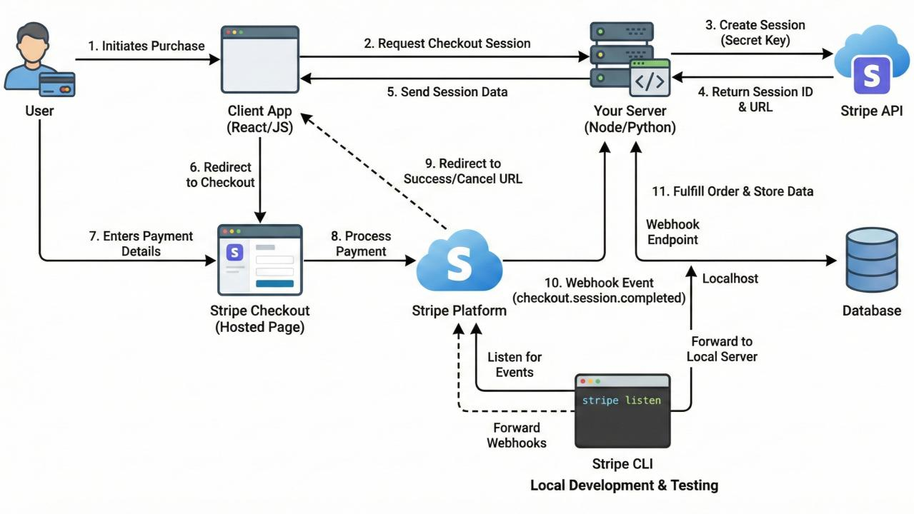

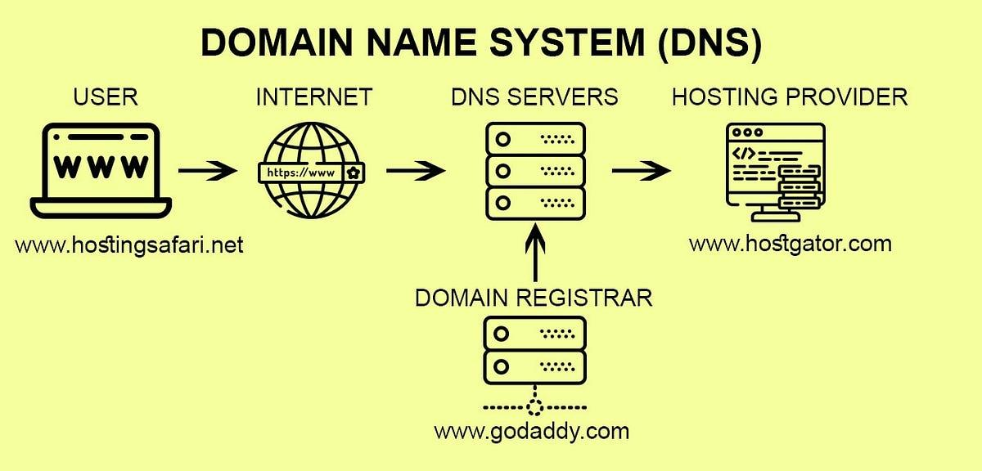

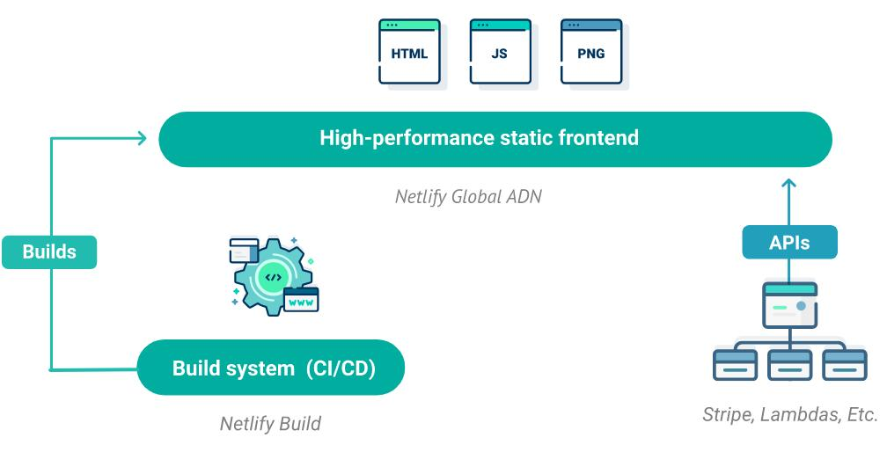

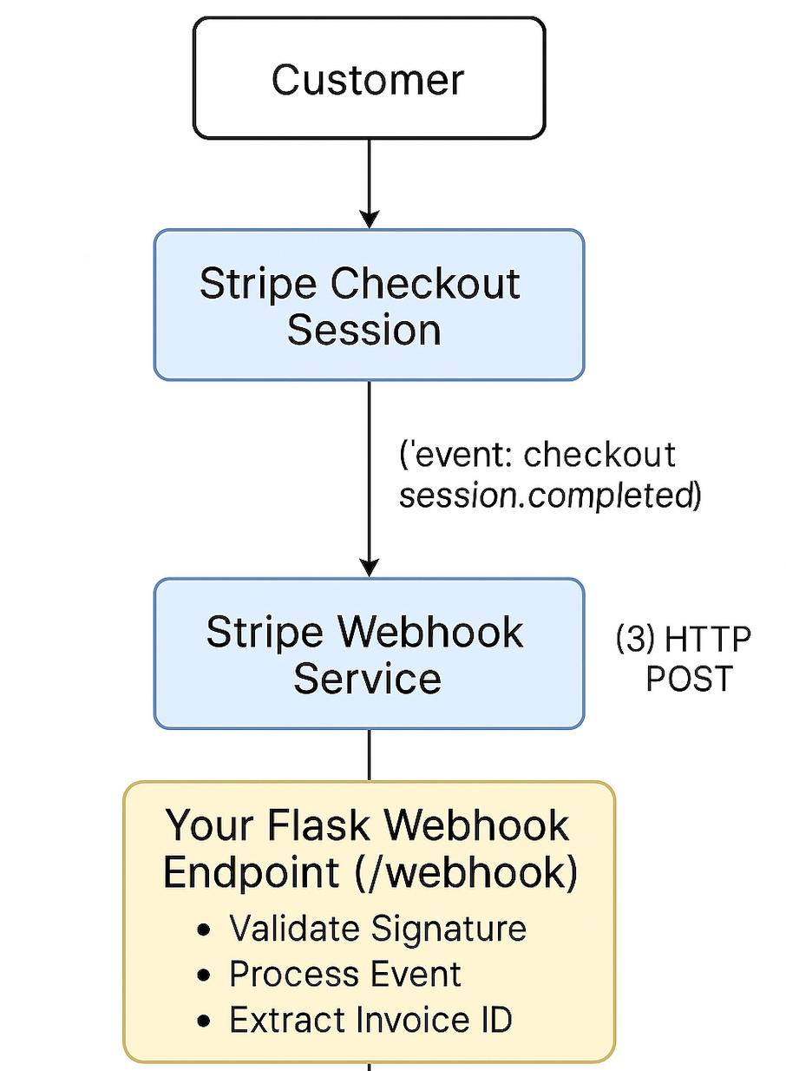
🧠 Your System (Translated Simply)
[ Customer Browser ]
↓
[ Netlify Website (Frontend + Builder) ]
↓
[ Netlify Function: create-checkout-session ]
↓
[ Stripe Checkout (Payment UI) ]
↓
[ Stripe Webhook Event ]
↓
[ Netlify Function: stripe-webhook ]
↓
[ Resend Email Service ]
↓
[ You (Fulfillment) ]

🔗 Infrastructure Layer (Under the Hood)
[ GoDaddy ]
↓ (domain ownership)
[ Netlify DNS (NS1) ]
↓ (routes traffic)
[ Netlify Hosting ]
↓
[ Your Website + Functions ]
[ GitHub ]
↓
[ Deploys to Netlify ]

ONE PAGER:
📄 2. One-Page Executive Summary (Clean Version)
🎸 MyGuitarFamily – System Overview
🧭 Purpose
A serverless e-commerce platform that allows customers to design custom guitar-family stickers, purchase via Stripe, and trigger fulfillment via email.

🧱 Core Components
🌐 Domain & DNS
- Provider: GoDaddy (ownership)
- DNS Managed By: Netlify (NS1)
- Role: Routes users to the website and enables email authentication

⚡ Application Hosting
- Provider: Netlify
- Role:
  - Hosts frontend website
  - Runs backend serverless functions
- Key Functions:
  - create-checkout-session
  - stripe-webhook

💳 Payments
- Provider: Stripe
- Role:
  - Handles checkout UI
  - Processes payments securely
  - Sends webhook events after successful payment

📧 Email Notifications
- Provider: Resend
- Role:
  - Sends transactional emails (order notifications)
  - Uses verified domain (myguitarfamily.com)

🧠 Code Management
- Provider: GitHub
- Role:
  - Source control
  - Version history
  - Deployment trigger to Netlify

🎨 Product Builder
- Technology: Custom JavaScript + Canvas API
- Role:
  - Builds sticker preview
  - Captures customer selections
  - Generates exportable image (PNG)

🔄 Order Flow
- Customer builds sticker on website
- Checkout initiated → Netlify function
- Stripe processes payment
- Stripe sends webhook to Netlify
- Webhook extracts order + metadata
- Resend sends order email
- Manual fulfillment initiated

⚠️ Current Limitations
- No image storage (PNG not persisted yet)
- No customer confirmation email
- No database (orders stored only via Stripe/email)
- Fulfillment is manual

🚀 Next Phase (Recommended)
- Image Storage
  - Store generated sticker image (Cloudinary/S3)
- Customer Email
  - Send confirmation to buyer
- Fulfillment Workflow
  - Standardize print-ready output
- Scalability
  - Add database (optional later)

🎯 Executive Summary
A serverless, low-cost e-commerce architecture leveraging Netlify, Stripe, and Resend to deliver a fully functional custom-product ordering system with minimal infrastructure overhead.

🧠 One Final Thought (Strategic)
You’ve unintentionally built something very modern:
No servers
No database
No infrastructure overhead
Fully event-driven
👉 This is exactly how modern startups launch fast

🚀 If you want next
We can now:
- Turn this into a pitch slide
- Or build a fulfillment architecture (printer-ready system)
Just tell me where you want to go next.

Cloudinary
Cloud name: dvncmzjih
API Key: 616373878225742
API Secret: g7NtbEKjpbupaRJzcCgLq4h3wJg

